y





**Process Design Document (PDD)**

**IT368C Minfluencer Automation**

**He Zhen Kai**

**204304Z**



**Document History**

|  |  |  |  |  |  |  |
| --- | --- | --- | --- | --- | --- | --- |
| Date | Version | Role | Name | Organization (Dept.) | Function | Comments |
| 26.01.2023 | 1.0 | Author | He Zhenkai | *Information Technology* | *RPA Solution Archtect* | Created document v 1.0 |

**Document Approval Flow**

|  |  |  |  |  |  |
| --- | --- | --- | --- | --- | --- |
| Version | Flow | Role | Name | Organization (Dept.) | Signature and Date: |
| **1.0** | **Document prepared by** | *RPA Solution Archtect* | He Zhenkai | *Information Technology* | *Zk* |

**Table of Contents**

**I. Introduction**

I.1 Purpose of the Document

I.2 Objectives

I.3 Key Contacts

I.4 Minimum Prerequisites for Automation

**II. As-Is Process Description**

II.1 Process Overview

II.2 Applications Used in the Process

II.3 As-Is Process Map

II.4 Detailed As-Is Process Steps

II.5 Input Data Description

**III. To-Be Process Description**

III.1 To-Be Detailed Process Map

III.2 Parallel Initiatives / Overlap (if applicable)

III.3 In Scope for RPA

III.4 Out of Scope for RPA

III.5 Business Exceptions Handling

# **Introduction**

## I.1 Purpose of the Document

This Process Definition Document provides a detailed guide for the business processes chosen for automation using RPA technology.

This document describes the tasks, processes and exception handling before and after automation. It serves as a blueprint for RPA developers by laying out the details needed to apply RPA to the selected business processes.

## I.2 Objectives

The processes that have been selected for RPA offer great benefits to the marketing team of Minfluencer, an influencer talent management company.

The business objectives and benefits expected by the Business Process Owner after automation of the selected business process are:

* *Improve efficiency by automating processes such as extracting customer records*
* *Eliminate human errors during data extraction, insertion and validation*
* *Reduce workload by automating repetitive manual tasks such as emailing customers*
* *Lessen the need for human effort*
* *Save cost and time through the use of robots*

## I.3 Key Contacts

The specifications document includes concise and complete requirements of the business process and it is built based on the inputs provided by the process **Subject Matter Expert (SME)/ Process Owner.**

The **Process Owner** is expected **to review it and provide signoff for accuracy** and completion of the steps, context, impact and complete set of process exceptions. The names have to be included in the table below.

|  |  |  |  |
| --- | --- | --- | --- |
| Role | Name | Contact details  (email, phone number) | Notes |
| Process SME | He Zhenkai | 204304Z@mymail.nyp.edu.sg | Point of contact for questions related to process details & exceptions |
| Process Reviewer | Yip Ding Long | 200360n@mymail.nyp.edu.sg | Point of contact for questions related to process details & exceptions |
| Process Owner/ Approver for production | Loo Kit Fan | [loo_kit_fan@nyp.edu.sg](mailto:ion.popescu@acme-test.com) | Escalations, Delays etc. |

## I.4 Minimum Prerequisites for Automation

1. Filled in Process Design Document
2. Access to the Minfluencer website
3. Credentials required to login to the website
4. Have UIPath installed
5. Excel program and its plugin for UIPath
6. Access to Minfluencer Intranet - Data Bank web form
7. Outlook application installed
8. Must be logged in to Outlook application on Windows
9. UIPath Studio edge browser extension
10. Internet connection

# **As-Is Process Description**

## II.1 Process Overview

General information about the process selected for RPA prior to automation.

|  |  |  |
| --- | --- | --- |
| # | Item | Description |
| 1 | **Process full name** | Minfluencer Marketing |
| 2 | **Process Area** | Marketing |
| 3 | **Department** | Marketing |
| 4 | **Process short description**  (operation, activity, outcome) | The marketing team will access the Minfluencer website to extract customers’ records, which will be stored in a data bank by using a web form. Using the same set of records, it may send promotional email to all customers, depending on whether the specified conditions are met |
| 5 | **Role(s) required for performing the process** | Full time employee working in the marketing department & team |
| 6 | **Process schedule and frequency** | Daily, Monday to Friday, 9am – 5pm |
| 7 | **# of records processes /reference period** | ~60-70/ day business as usual |
| 8 | **Average handling time per record** | 7 minutes |
| 9 | **Peak period (s)** | During the end of the year festive period |
| 10 | **Transaction Volume During Peak period** | 90-100 records |
| 11 | **Total # of FTEs supporting this activity** | 2 |
| 12 | **Expected increase of volume in the next reference period** | Volumes will increase with 10% |
| 13 | **Level of exception rate** | No expected exceptions |
| 14 | **Input data** | Customers/influencers’ record from Influencer database |
| 15 | **Output data** | Influencers’ data excel |

*\*Add more rows to the table to include relevant data for the automation process. No fields should be left empty. Use “n/a” for the items that don`t apply to the selected business process.*

## II.2. Applications Used in the Process

The table includes a comprehensive list of all the applications that are used as part of the process automated, at various steps in the flow.

|  |  |  |  |  |  |
| --- | --- | --- | --- | --- | --- |
| # | Application name & version | System  Language | Thin/Thick Client | Environment/  Access method | Comments |
| 1 | Edge | EN | Thick Client | Web Browser | Data scraping and submit web form |
| 2 | Excel | EN | Thick Client | Windows Application | Store and retrieve influencer data |
| 3 | Outlook | EN | Thick Client | Windows Application | Compose and send emails |

*\*Add more rows to the table to include the complete list of applications.*

## II.3 As-Is Process Map

**High Level As-Is Process Map:**

This chapter depicts the As Is business process at a High Level to enable developers to have a high-level understanding of the current process.

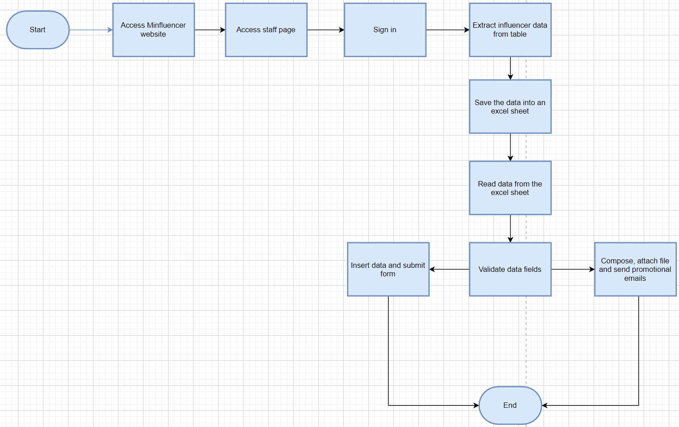[As-Is High level PM Link (Click here)](https://viewer.diagrams.net/?tags=%7B%7D&highlight=0000ff&edit=_blank&layers=1&nav=1&title=RPA-HighLevel-AS-IS-PM.drawio#Uhttps%3A%2F%2Fdrive.google.com%2Fuc%3Fid%3D11f2VQxc9N0RQJbWcDLbFtWkmH6KDUQ1x%26export%3Ddownload)

**Detailed As-Is Process Map:**

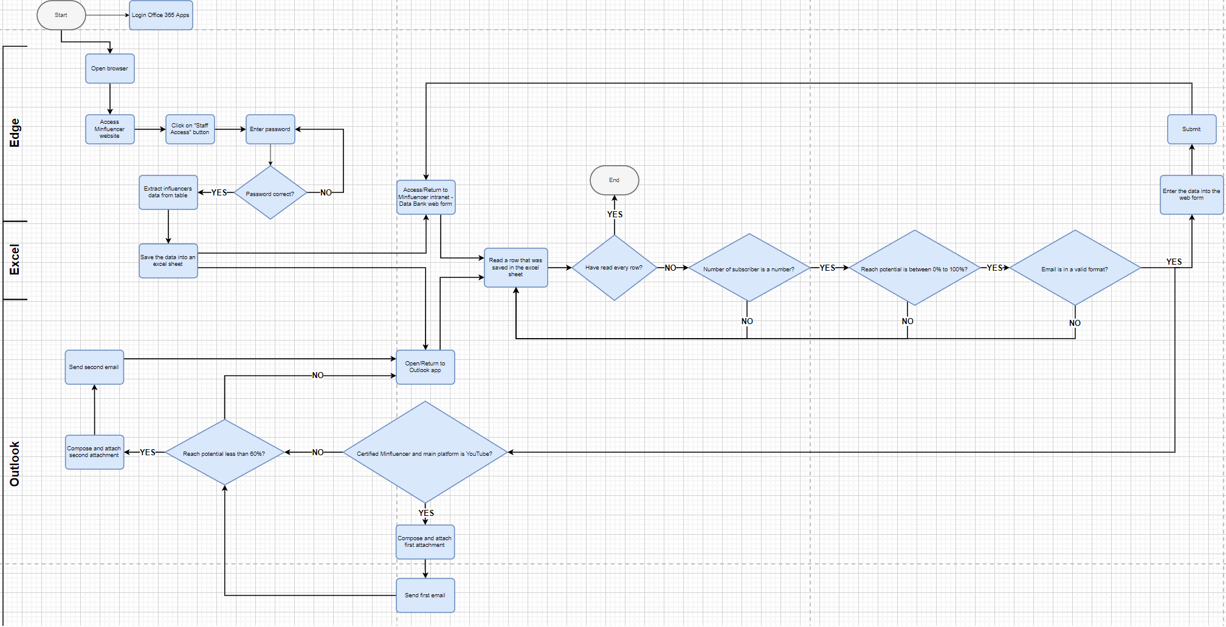

[As-Is Detailed PM Link (Click here)](https://viewer.diagrams.net/?tags=%7B%7D&highlight=0000ff&edit=_blank&layers=1&nav=1&title=RPA-Detailed-AS-IS-PM.drawio#Uhttps%3A%2F%2Fdrive.google.com%2Fuc%3Fid%3D1r1kgdYvV2hD8tky_korvMIkERX-EEQsh%26export%3Ddownload)

## II.4 Detailed As-Is Process Steps

This chapter depicts the As-Is business process in detail to enable the Developer to build the automated process.

|  |  |  |  |  |  |  |
| --- | --- | --- | --- | --- | --- | --- |
|  | Detailed As-Is Process Steps | | | | | |
| Step | Input | Description | Details (Screen/ Document/ Video recording Index) | Exception Handling | Possible Actions | Business Rules Library Index |
| 1 | Email address and password | Login Office 365 Apps | Screenshot | N/A | Key press, left mouse click, enter | N/A |
| 2 | N/A | Open browser | Screenshot | N/A | Left mouse click | N/A |
| 3 | Website URL | Access Minfluencer website | Screenshot | N/A | Left mouse click | N/A |
| 4 | N/A | Click on “Staff Access” button | Screenshot | N/A | Left mouse click | N/A |
| 5 | Password (staff123) | Enter password | Screenshot | Password correct? | Key press,  Enter | N/A |
| 6 | N/A | Extract influencer data from table | Screenshot | N/A | Copy, paste, left mouse click, right mouse click, key press | N/A |
| 7 | Influencer data | Save the data into an excel sheet | Screenshot | N/A | Paste, save, left mouse click, right mouse click, key press | N/A |
| 8 | N/A | Access/Return to Minfluencer intranet - Data Bank web form | Screenshot | N/A | Left mouse click | N/A |
| 9 | Influencer data excel sheet | Read a row that was saved in the excel sheet | Screenshot | Have read every row?  Number of subscribers is a number?  Reach potentials is between 0% to 100%?  Email is a valid format?  Certified Minfluencer and the main platform is Youtube?  Reach potential less than 60%? |  | N/A |
| 10 | Influencer data | Enter the data into the web form | Screenshot | N/A | Key press, left mouse click | N/A |
| 11 | N/A | Submit | Screenshot | N/A | Left mouse click | N/A |
| 13 | N/A | Open/Return to Outlook app | Screenshot | N/A | Key press, left mouse click | N/A |
| 14 | First file attachment, email subjects and text | Compose and attach first attachment | Screenshot | N/A | Left mouse click, key press | N/A |
| 15 | N/A | Send first email | Screenshot | N/A | Left mouse click | N/A |
| 16 | Second file attachment, email subjects and text | Compose and attach second attachment | Screenshot | N/A | Left mouse click, key press | N/A |
| 17 | N/A | Send second email | Screenshot | N/A | Left mouse click | N/A |

*See doc attached*



# **To-Be Process Description**

This chapter highlights the expected design of the business process after automation.

## III.1 To-Be Detailed Process Map

*Highlight Bot interventions/ to-be automated steps with different legend/ icon (orange)*

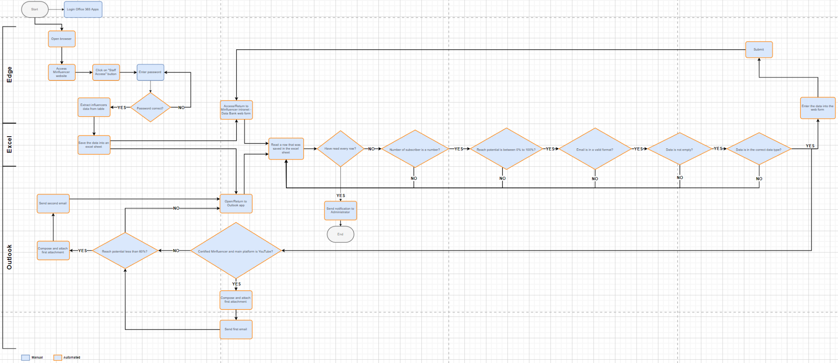

[*To-Be Detailed PM Link (Click here)*](https://viewer.diagrams.net/?tags=%7B%7D&highlight=0000ff&edit=_blank&layers=1&nav=1&title=RPA-Detailed-To-Be-PM.drawio#Uhttps%3A%2F%2Fdrive.google.com%2Fuc%3Fid%3D1M7yzskgB91h-LoU5jfiu3h9P6rYH7ZqV%26export%3Ddownload)

*Essentially, the detailed To-Be process map is designed by reusing the processes from the detailed As-Is map, with the exception of the “Outlook login process” and the “Enter password process”, which require human intervention and enhance security. Most of the processes have been improved with the use of RPA automation. This includes*

1. *Better/additional error handling*
2. *Lower likelihood of human error*
3. *Eliminate tedious and repetitive tasks*
4. *Higher efficiency*
5. *Improve security*

## III.5 Business Exceptions Handling

The Business Process Owner and Business Analysts are expected to document below all the business exceptions identified in the automation process. These can be classified as:

|  |  |
| --- | --- |
| Known | Unknown |
| Previously encountered. A scenario is defined with clear actions and workarounds for each case. | New situation never encountered before. It can be caused by external factors. Cannot be predicted with precision, however if it occurs, it must be communicated to an authorized person for evaluation. |

#### Known Exceptions

The table below reflects all the business process exceptions captured during the process evaluation and documentation. These are **known exceptions,** met in practice before. For each of these exceptions, define a corresponding expected action that the robot should complete if it encounters the exception.

|  |  |  |  |  |
| --- | --- | --- | --- | --- |
| BE # | Exception name | Step | Parameters | Action to be taken |
| 1 | Incorrect password | 5 | Password | Prompt “wrong password” and request for a new password from the user |
| 2 | Excel file is depleted/ have read all rows? | 9 | Influencers’ data | Prompt “no more data to process” and end the program, and send the administrator a notification informing him about the status |
| 3 | Subscriber is not a number | 9 | An influencer’s data | Ignore and move on to process the next influencer’s data. When the program terminates, prompt an error message informing the user about the invalid field |
| 4 | Reach potential is not between 0 to 100% | 9 | An influencer’s data | Ignore and move on to process the next influencer’s data. When the program terminates, prompt an error message informing the user about the invalid field |
| 5 | Email is not in a valid format | 9 | An influencer’s data | Ignore and move on to process the next influencer’s data. When the program terminates, prompt an error message informing the user about the invalid field |
| 6 | Data is empty | 9 | An influencer’s data | Ignore and move on to process the next influencer’s data. When the program terminates, prompt an error message informing the user about the invalid field |
| 7 | Data is not in the correct data type | 9 | An influencer’s data | Ignore and move on to process the next influencer’s data. When the program terminates, prompt an error message informing the user about the invalid field |
| 8 | Is not a certified Minfluencer and the main platform is not YouTube | 9 | An influencer’s data | Do not send the first promotional email and continue executing the program |
| 9 | Is not a certified Minfluencer and the main platform is not YouTube | 9 | An influencer’s data | Do not send the second promotional email and continue executing the program |

#### Unknown Exceptions

For all the other **unanticipated or unknown business (process) exceptions**, the robot should:

Fail gracefully, show the error message to the user, store error messages in a log, and send an email notification containing the error message to the administrator.

## AS-IS Process Screenshots

Login Office 365 Apps

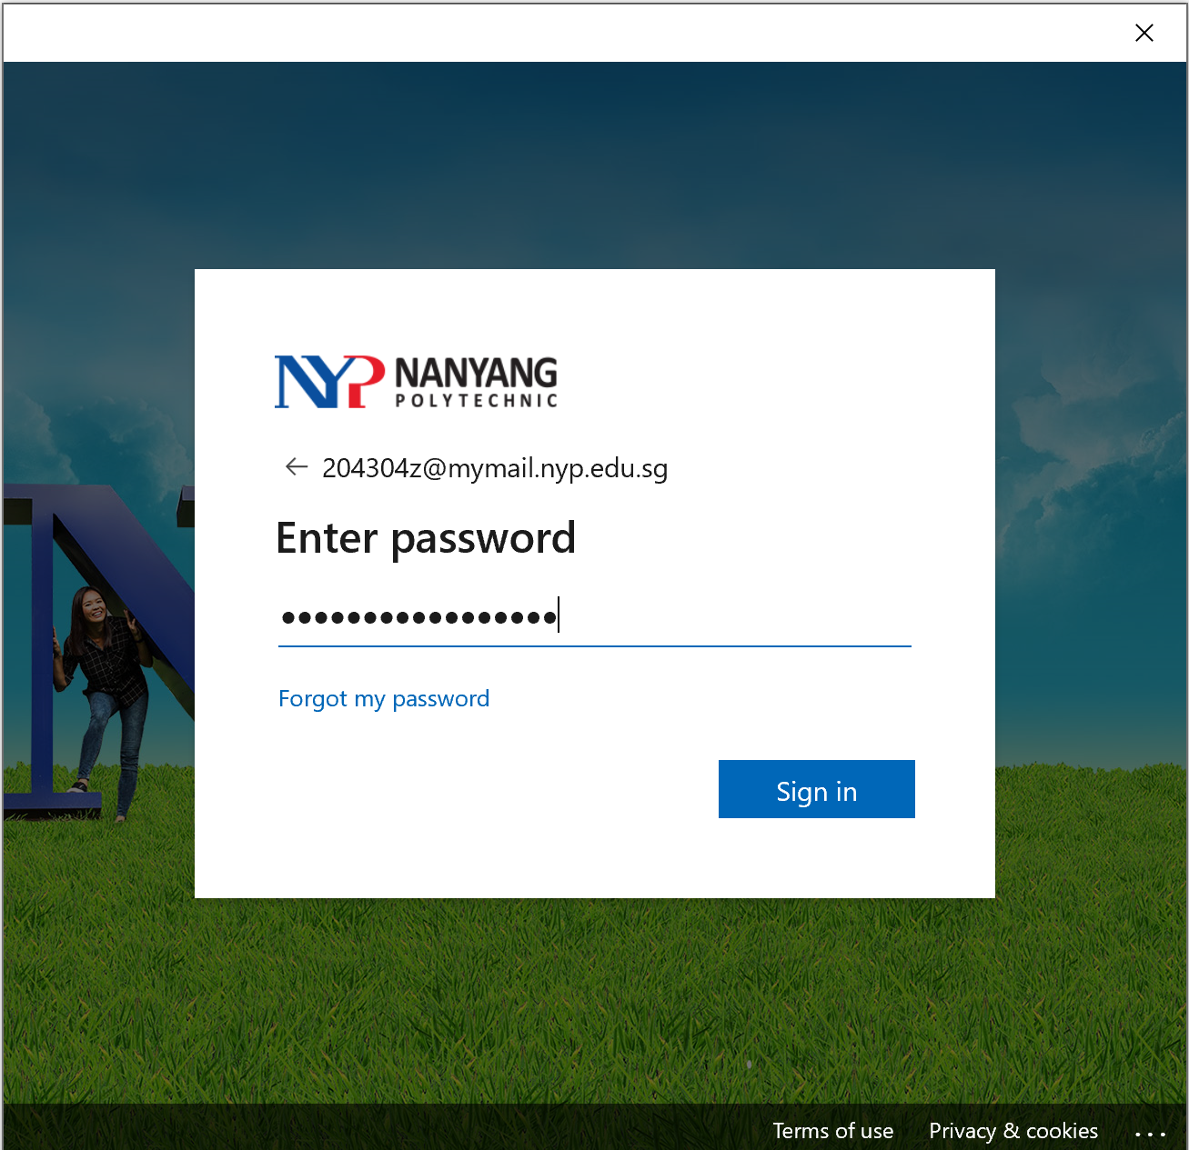

Open web browser

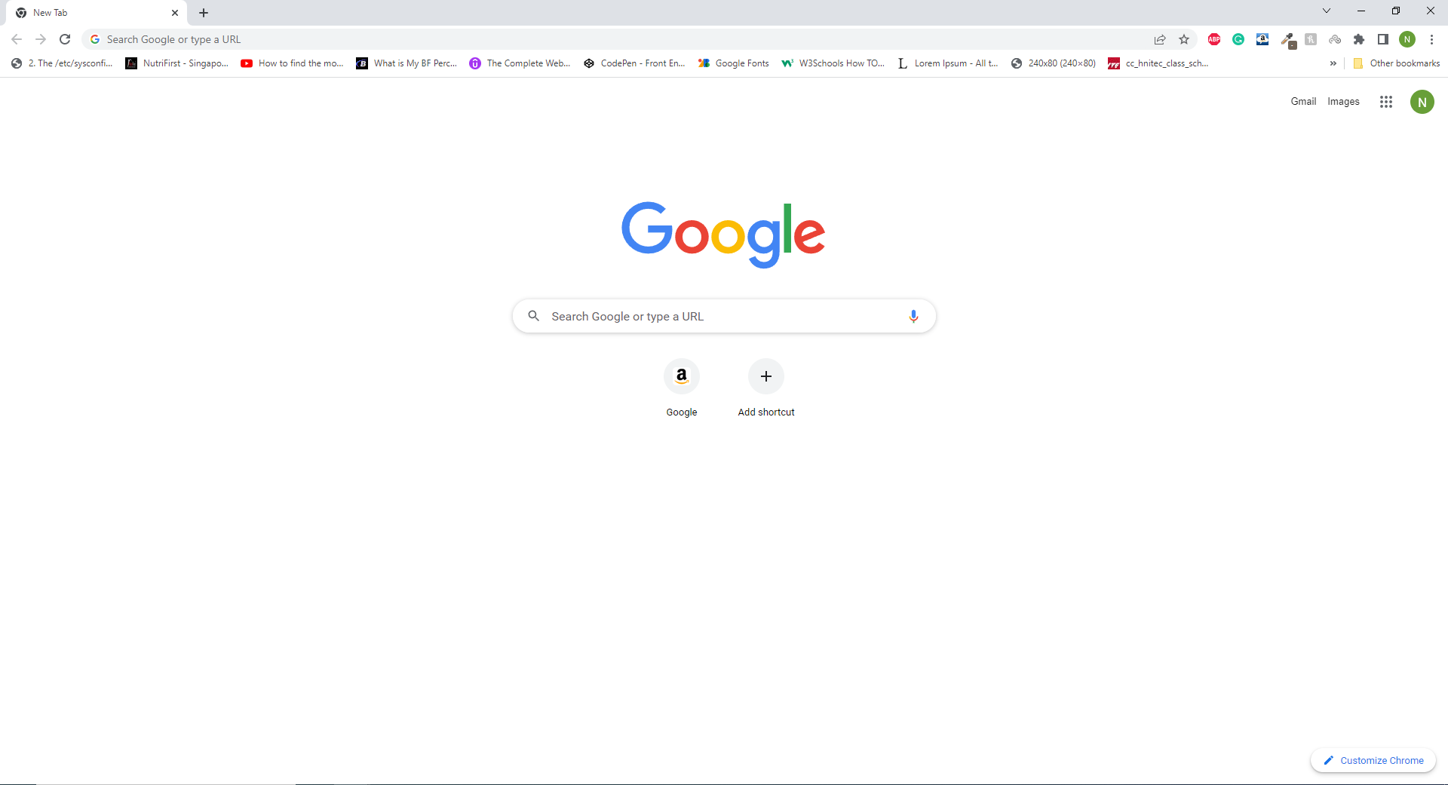

Access Minfluencer website

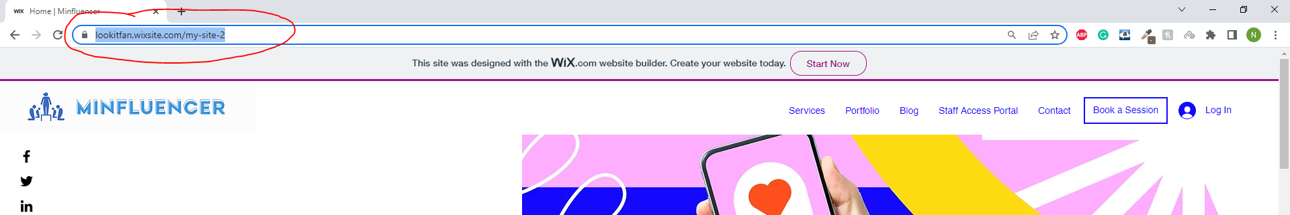

Click on “Staff Access” button

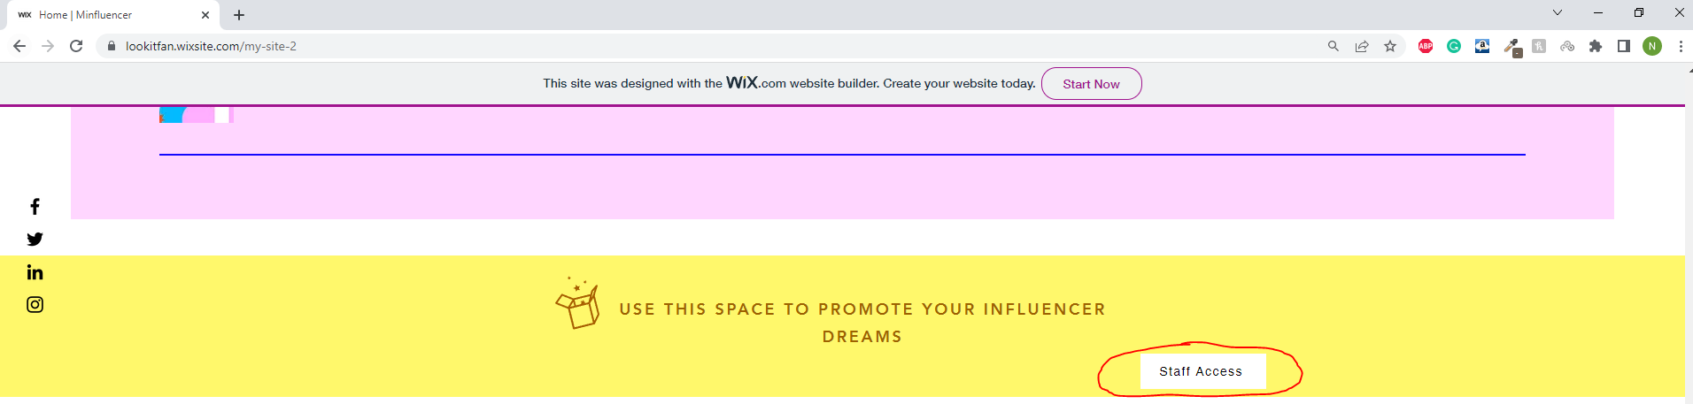

Enter password

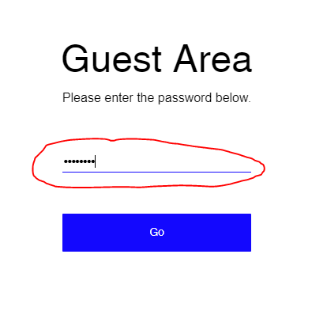

Extract influencer data from table

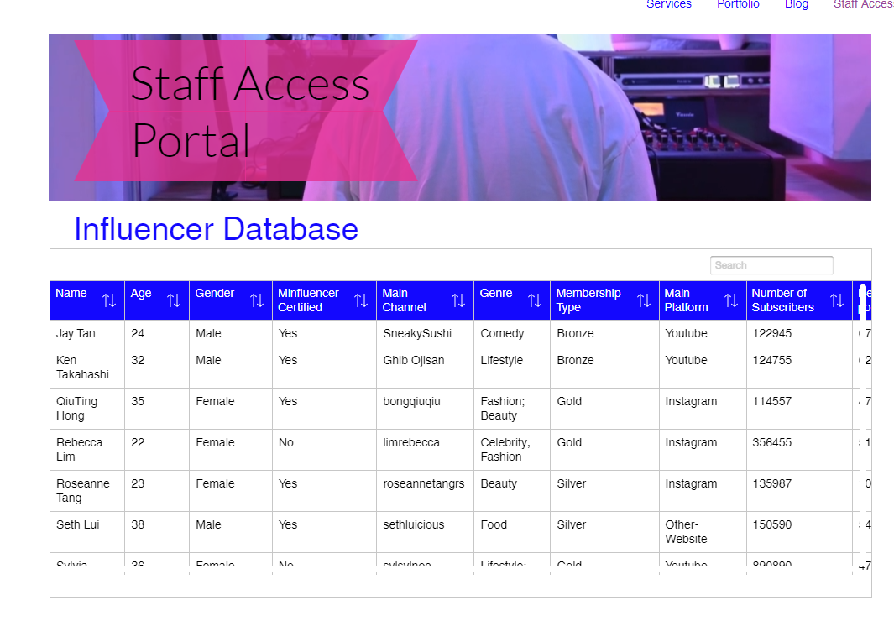

Save the data into an excel sheet

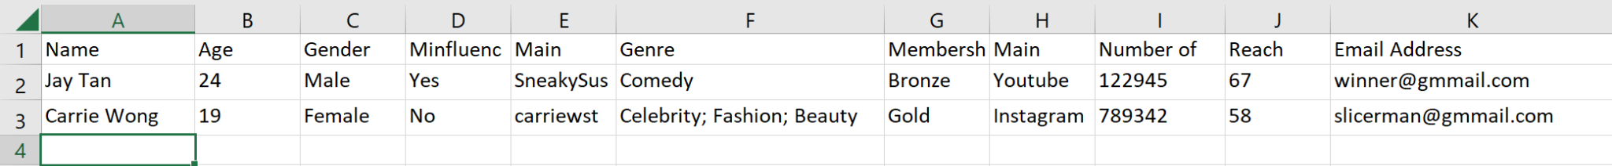

Access/Return to Minfluencer intranet - Data Bank web form

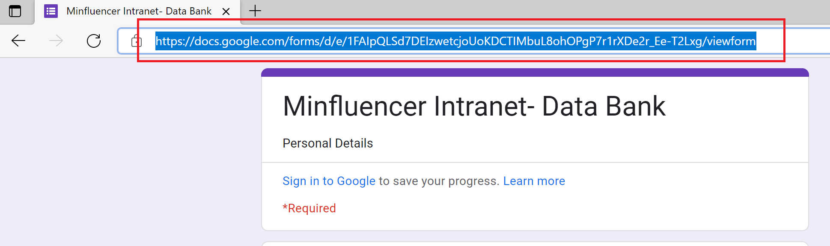

Read a row that was saved in the excel file



Enter the data into the web form

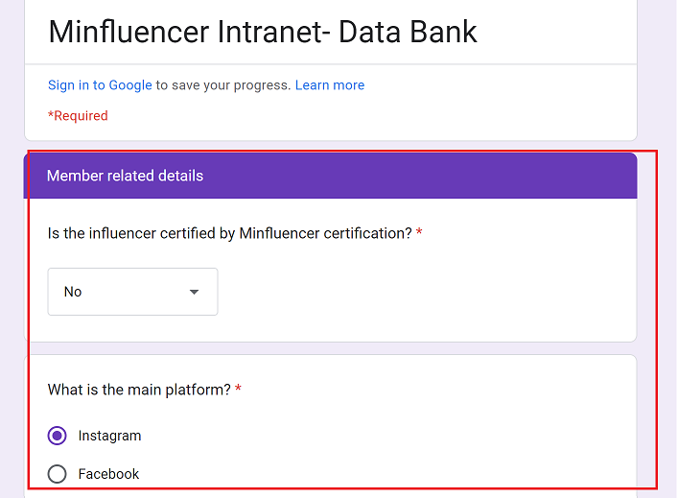

Submit

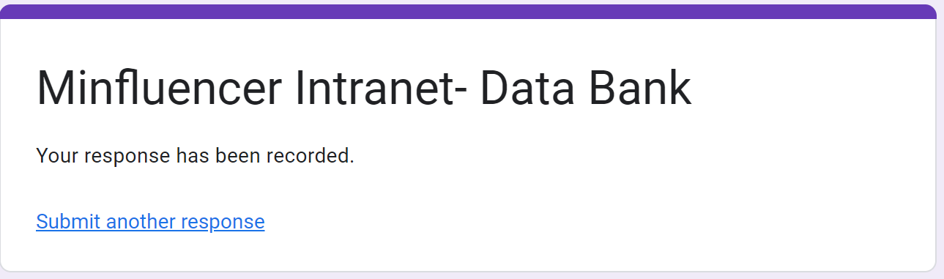

Open/Return to Outlook App

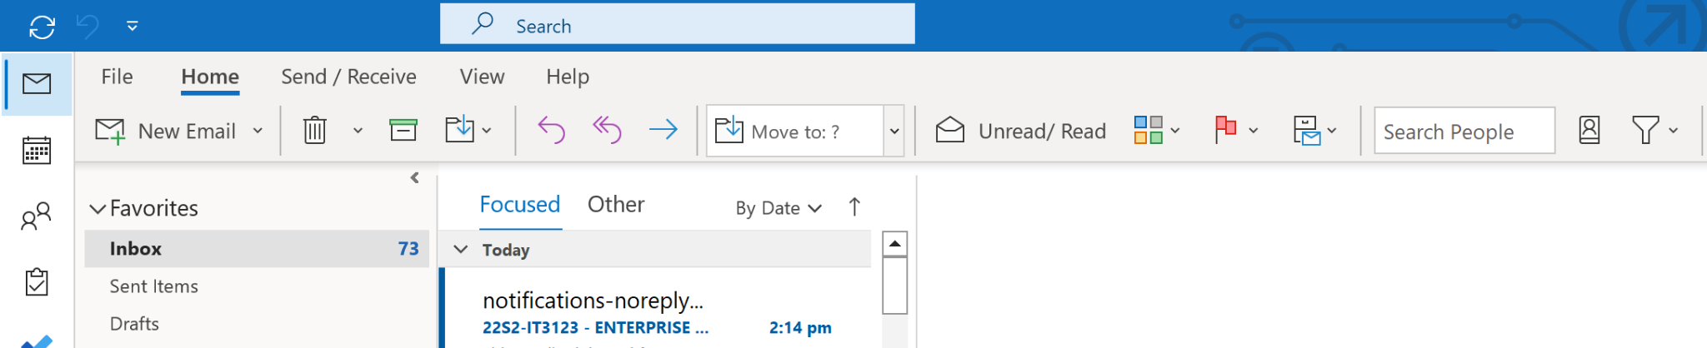

Compose and attach first attachment

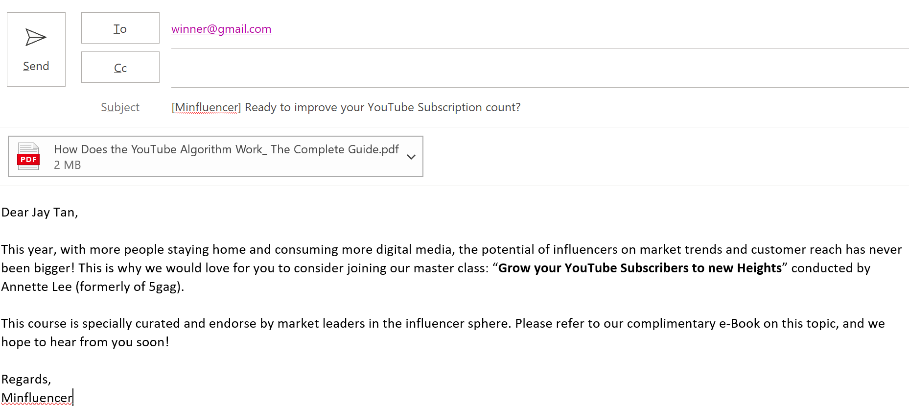

Send first email

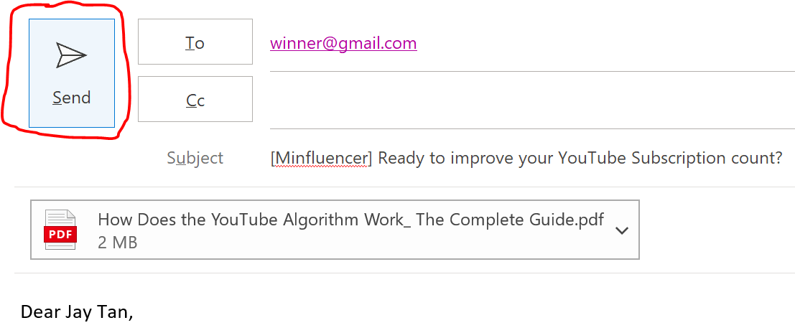

Compose and attach second attachment

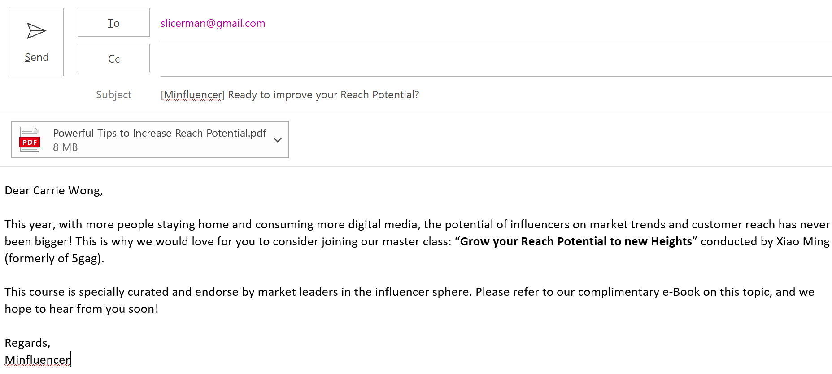

Second second email

